Nama : Nanda Amelia

Nim : 191402015

UTS Enterprise Development Software

SAP HANA

* MODULE 4 ( Connecting to and creating data on the SAP HANA CLOUD data lake)

1. Jika belum running, running kan terlebih dahulu SAP HANA database dan data lake

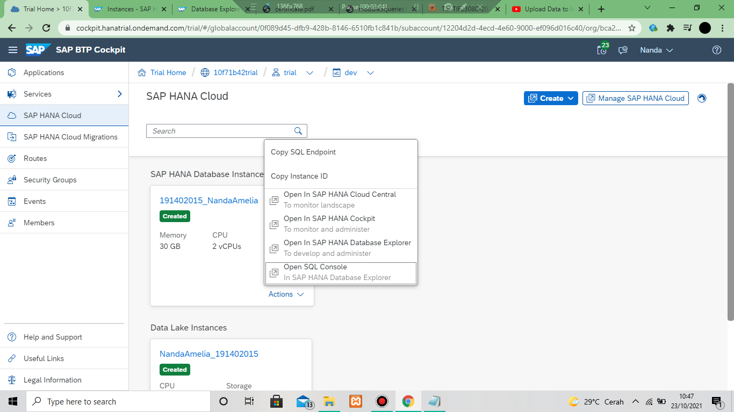

1. Buka open sql console

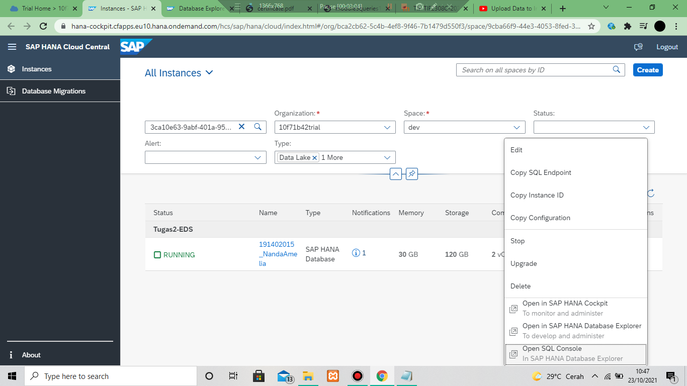

1. Buka remote source kemudian show remote source. Klik baguan SYSRDL#CG_SOURCE

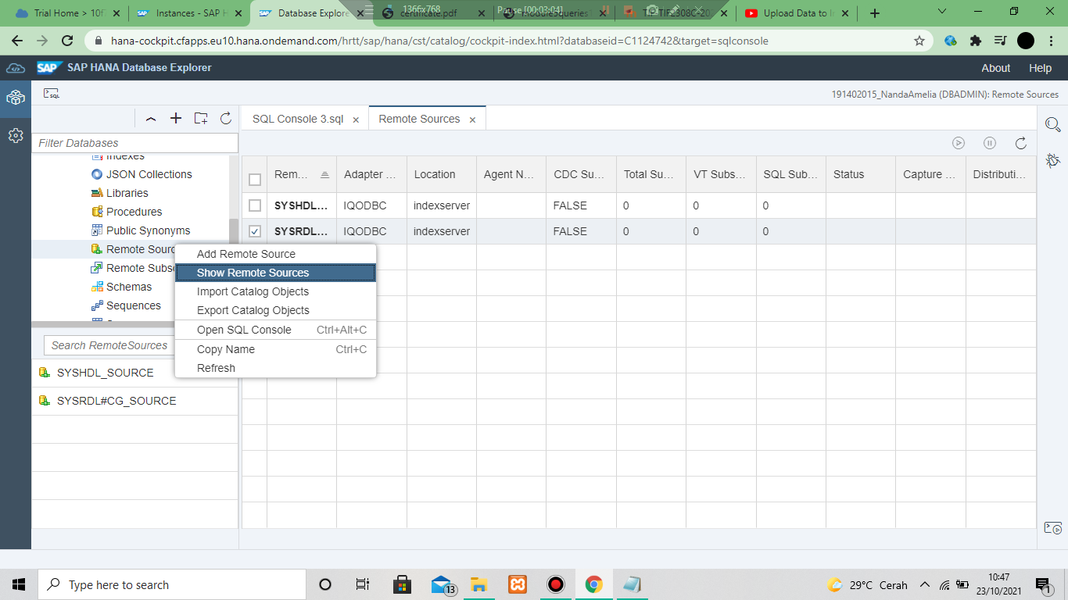

1. Ceklis Database selanjutnya create virtual object

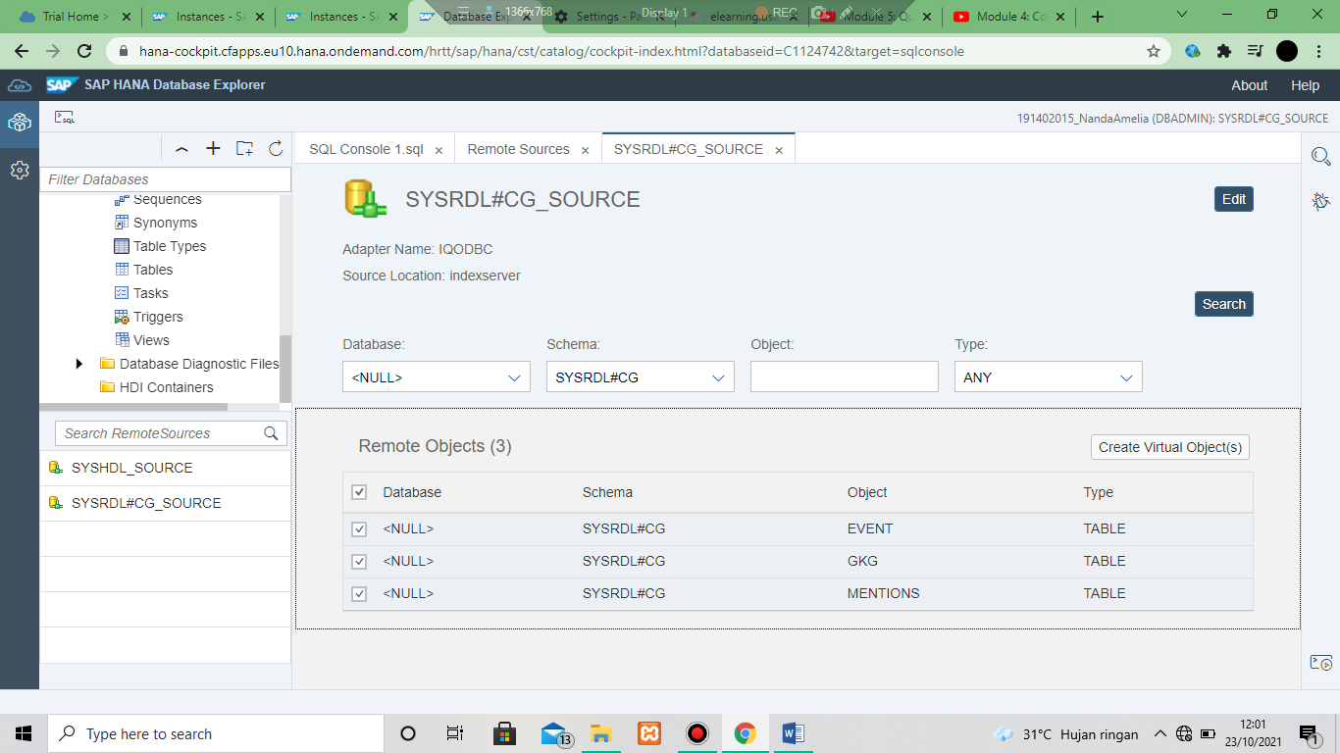

1. Ketik HDCL_ dan pilih SFLIGHT

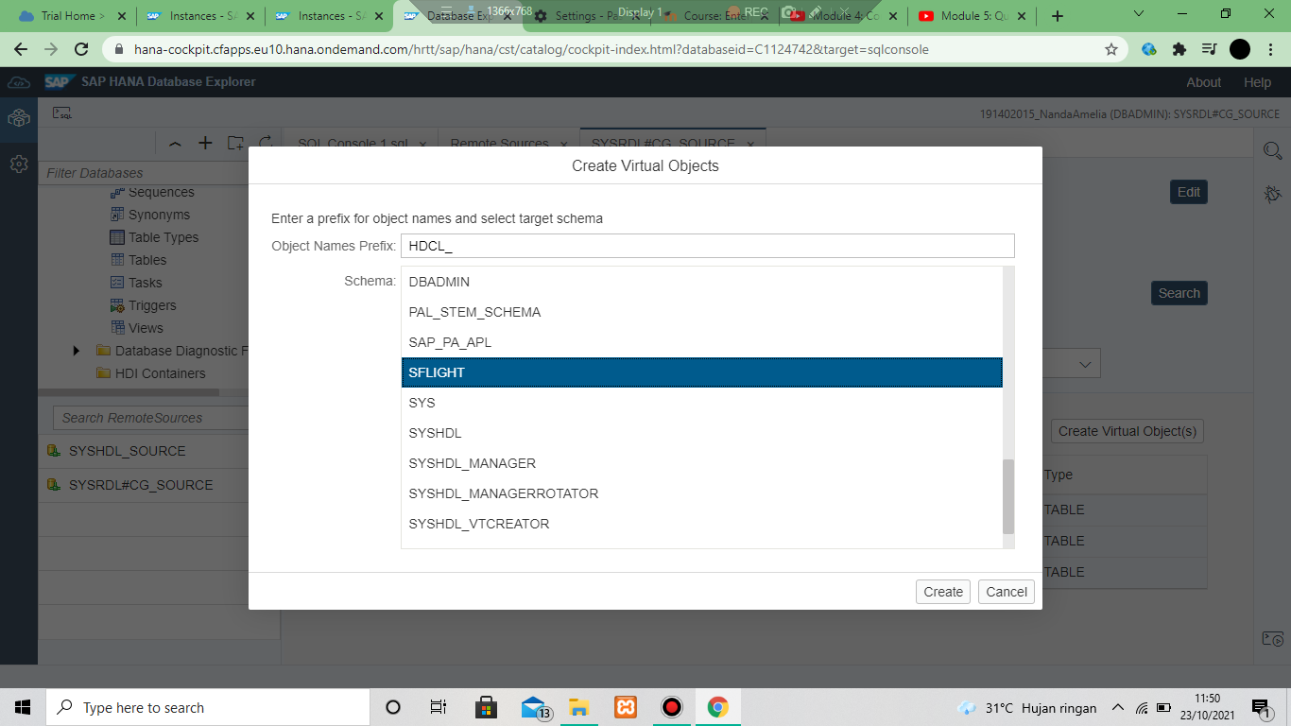

1. CREATE



* **MODULE 5 ( Query Data on SAP HANA Cloud)**

1. Set SCHEMA SFLIGHT

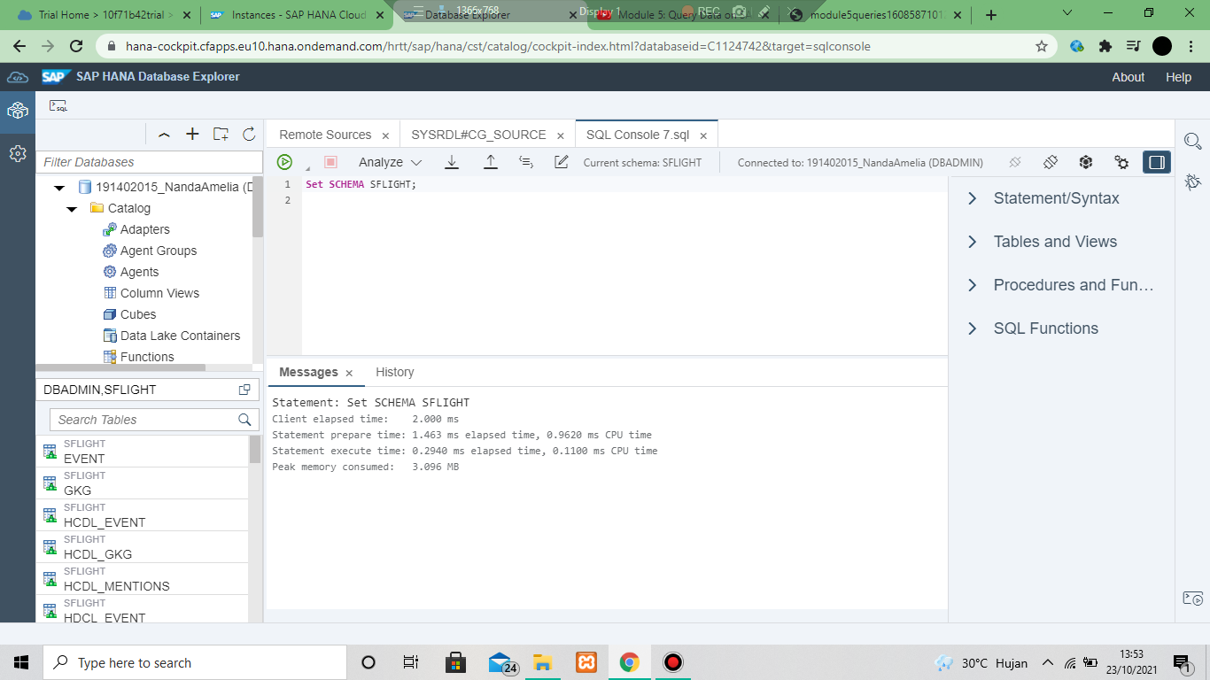

1. Query to create a new table SAGENCYDATA

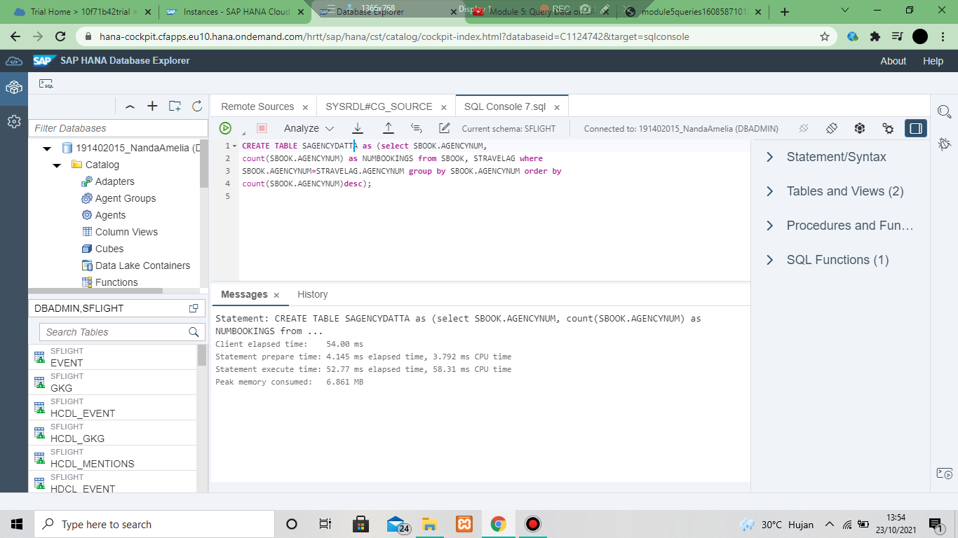

1. Memanggil data SAGENCYDAT

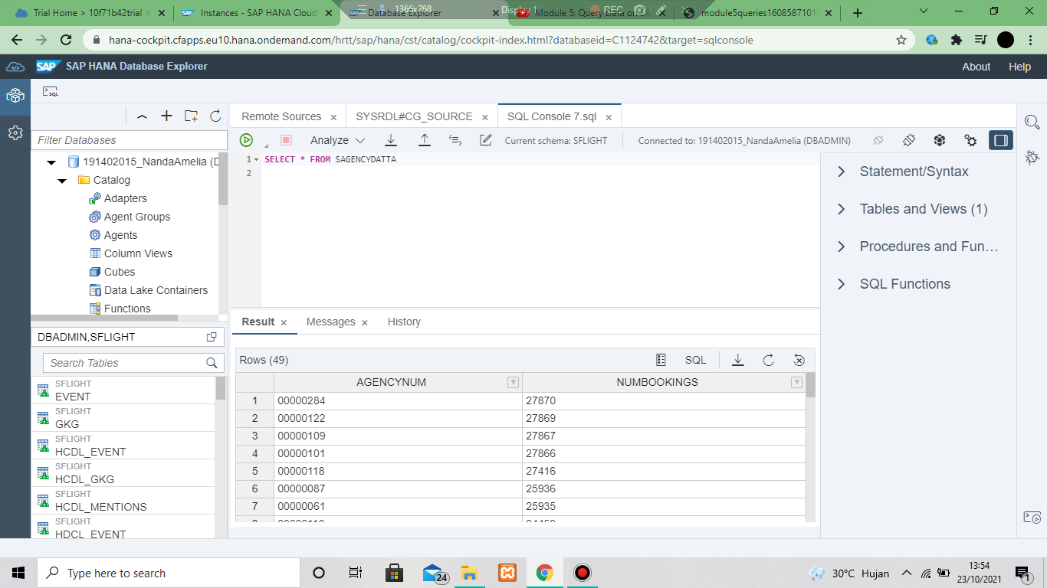

1. Query to select the top 5 agencies

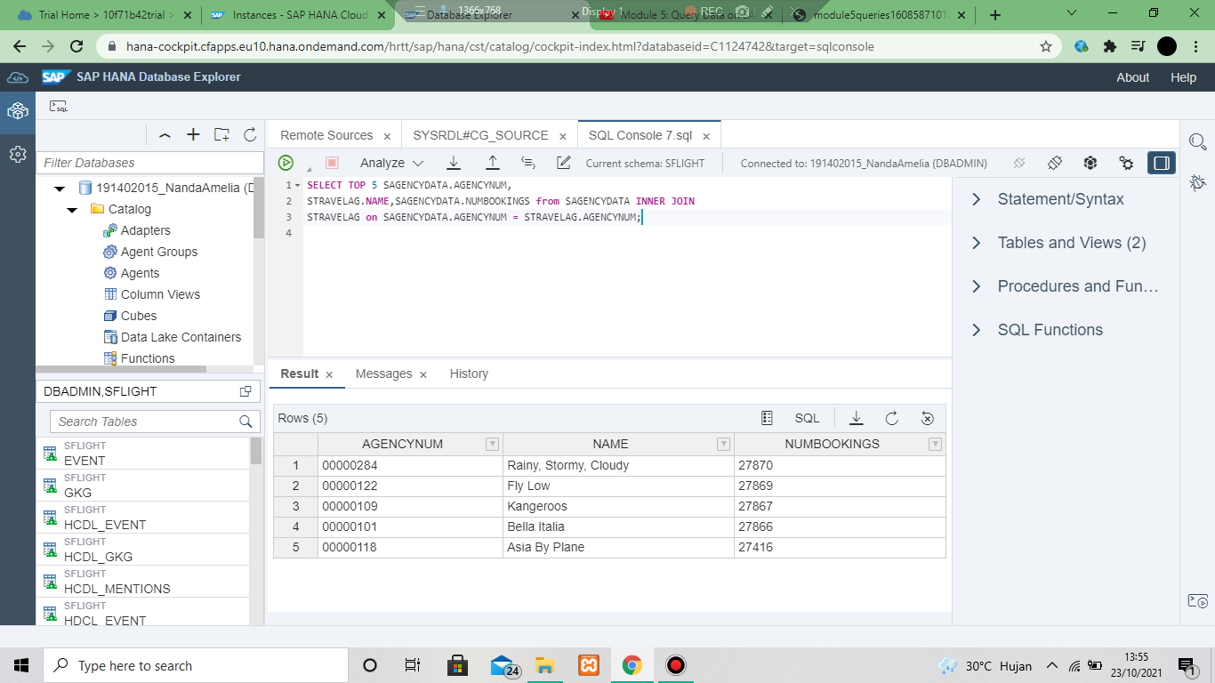

1. Query to create STOPAGENCY table

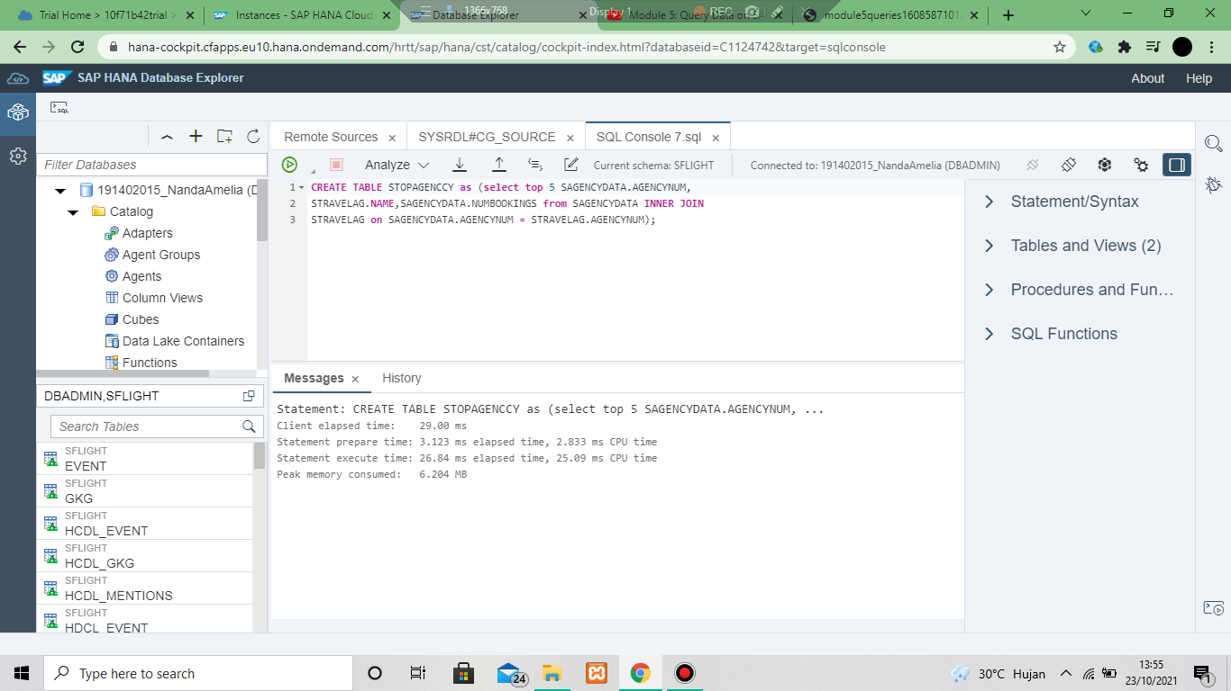

1. Memanggil STOPAGENCY

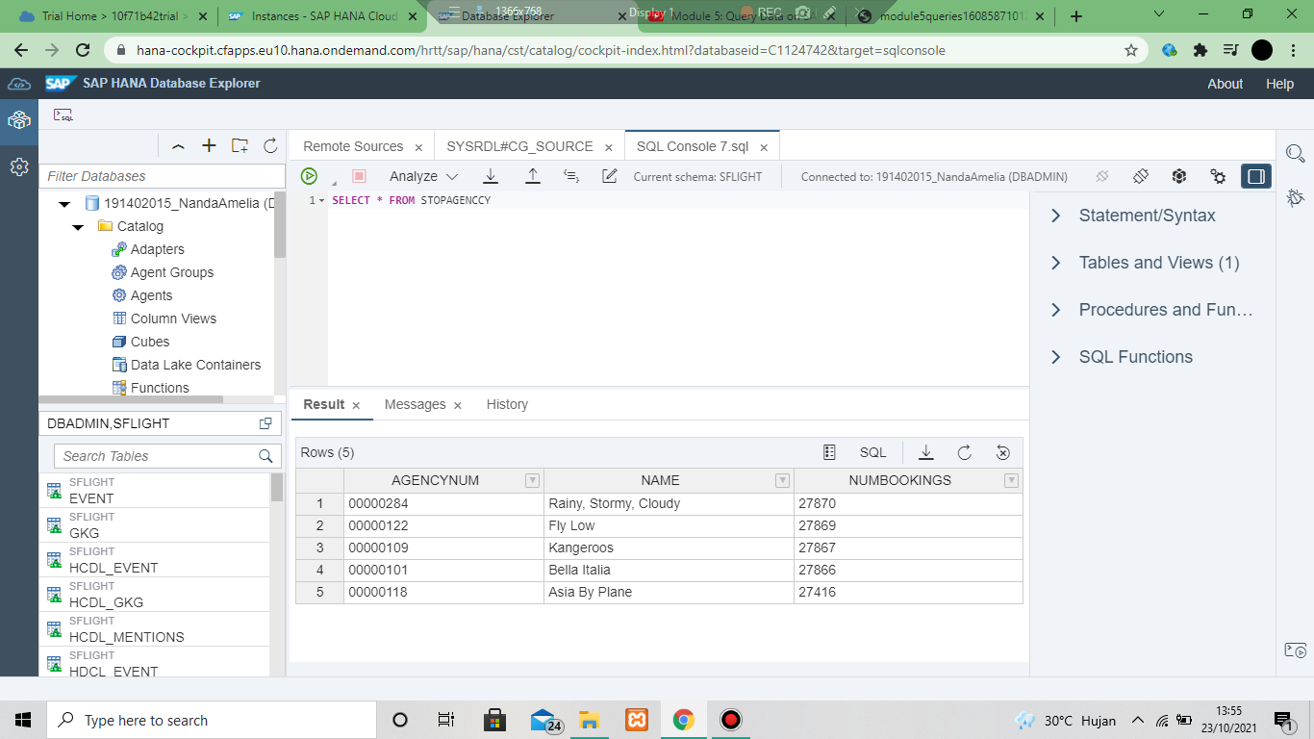

1. Query to create SAGBOOKDAYS table

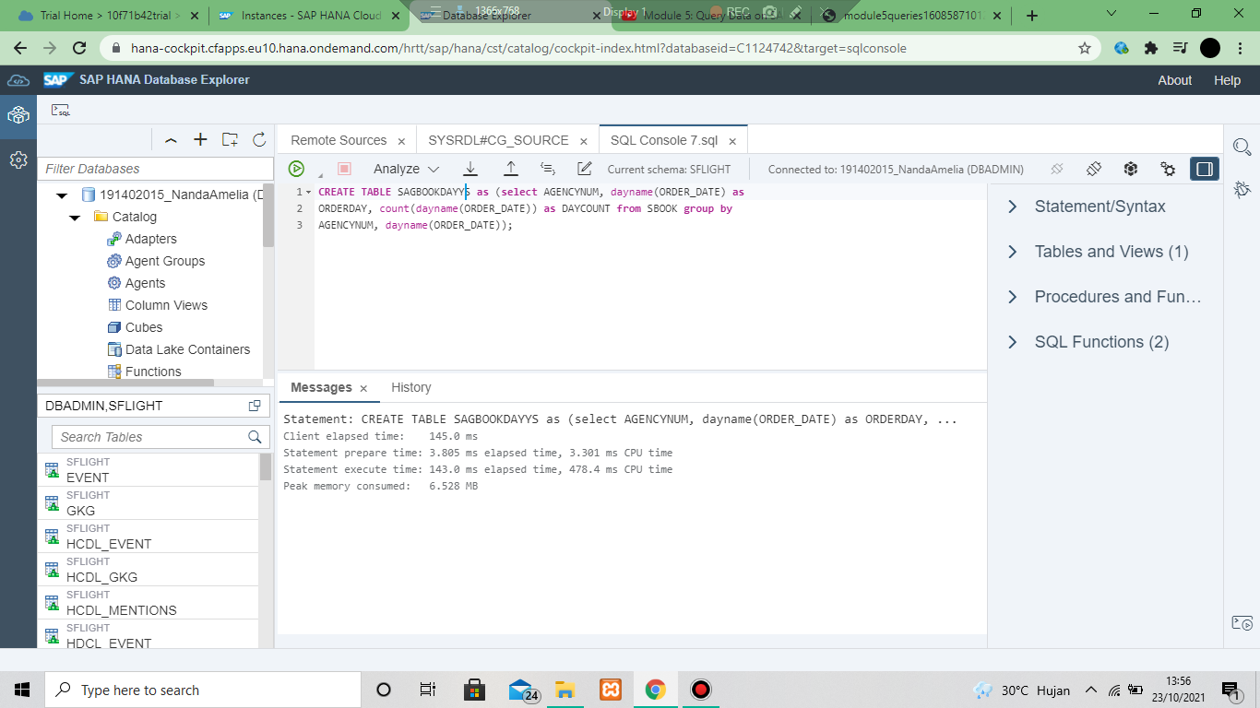

1. Memanggil SAGBOOKDAYS

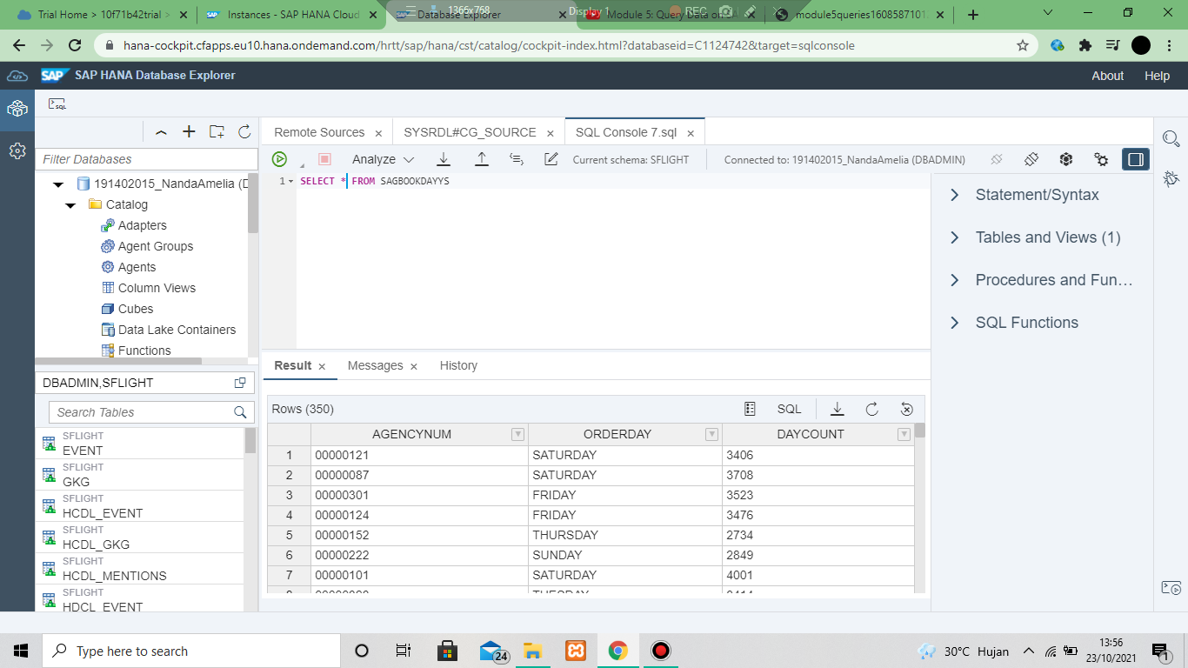

1. QUERY to get the max booking days for each of the top 5 agencies

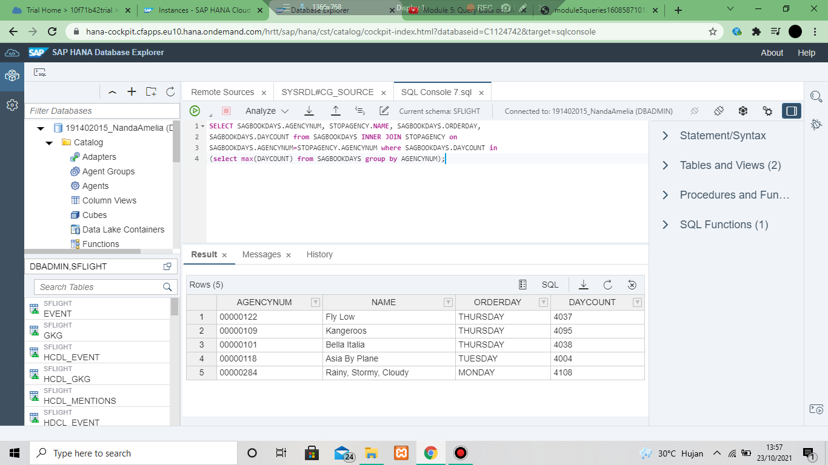

* Module 6 (Setting Up your First HANA project in SAP Business Aplication studio)

Trial – istance and subscription

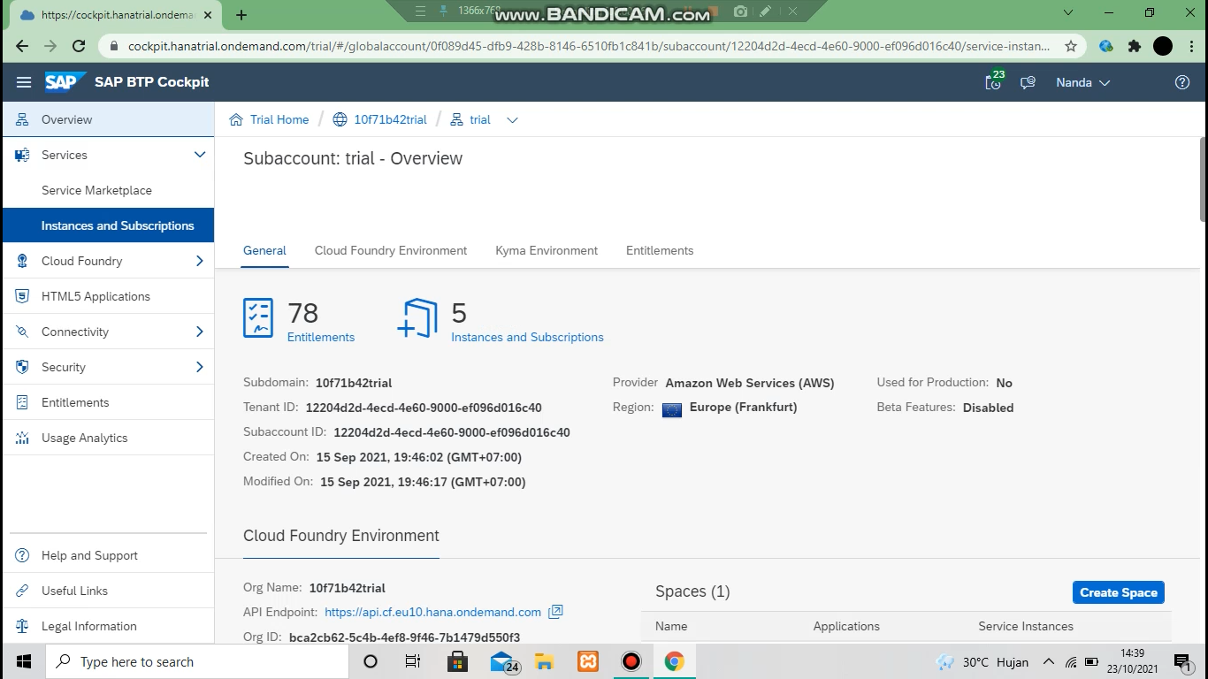

Subscribe - go to aplication

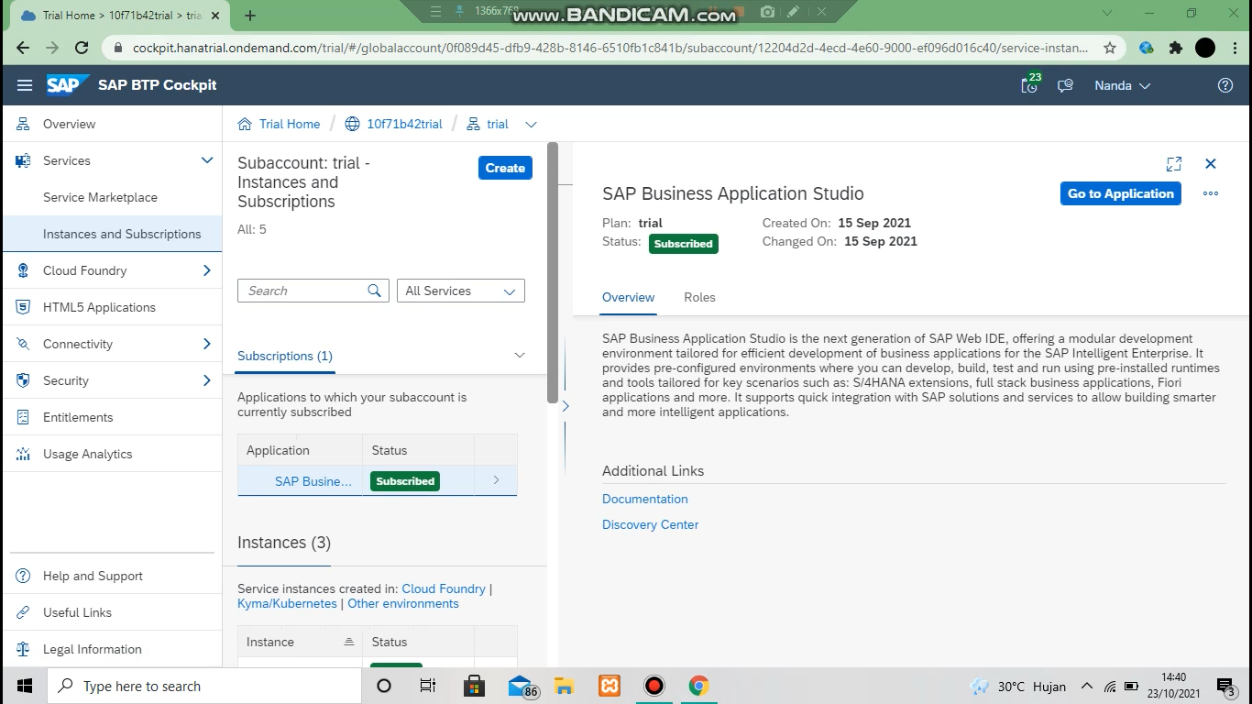

Craate a new space : BestRunTravel kemudian create

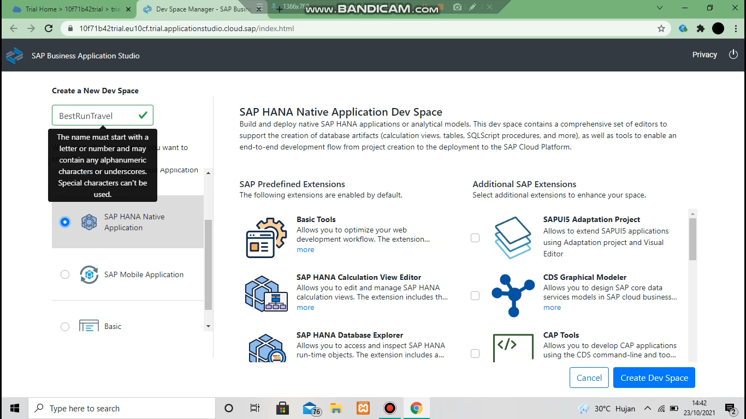

Kita tunggu sampai runing

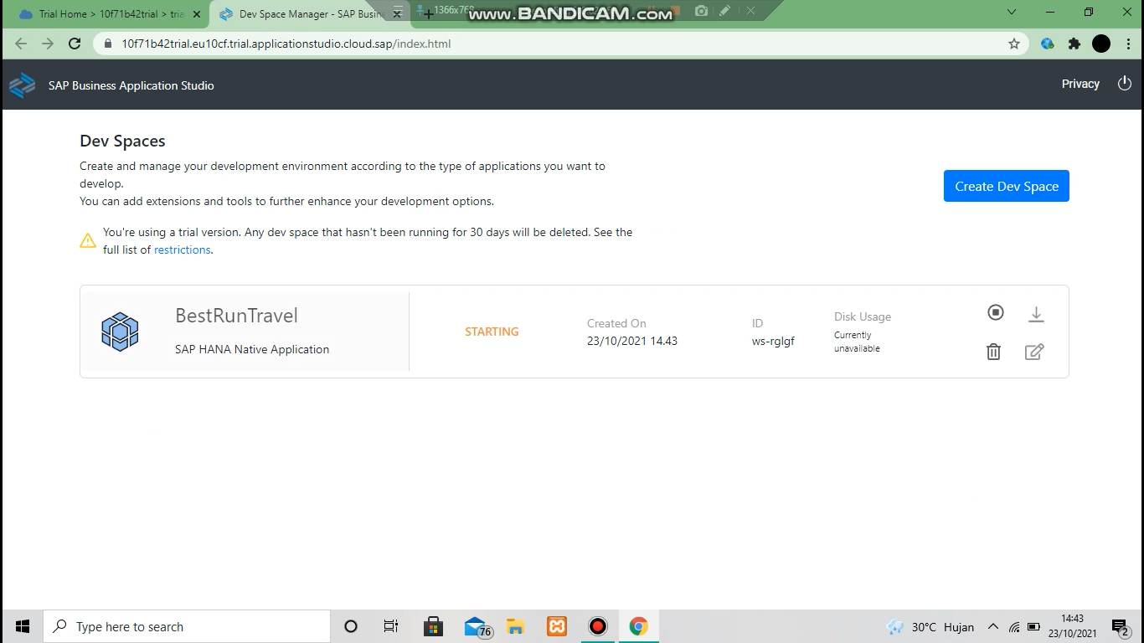

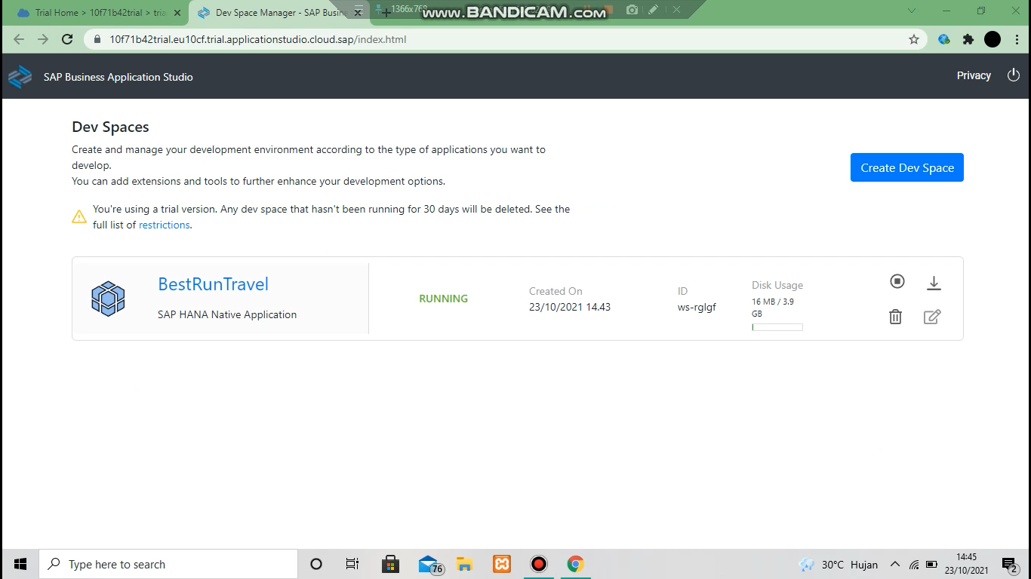

Start from template

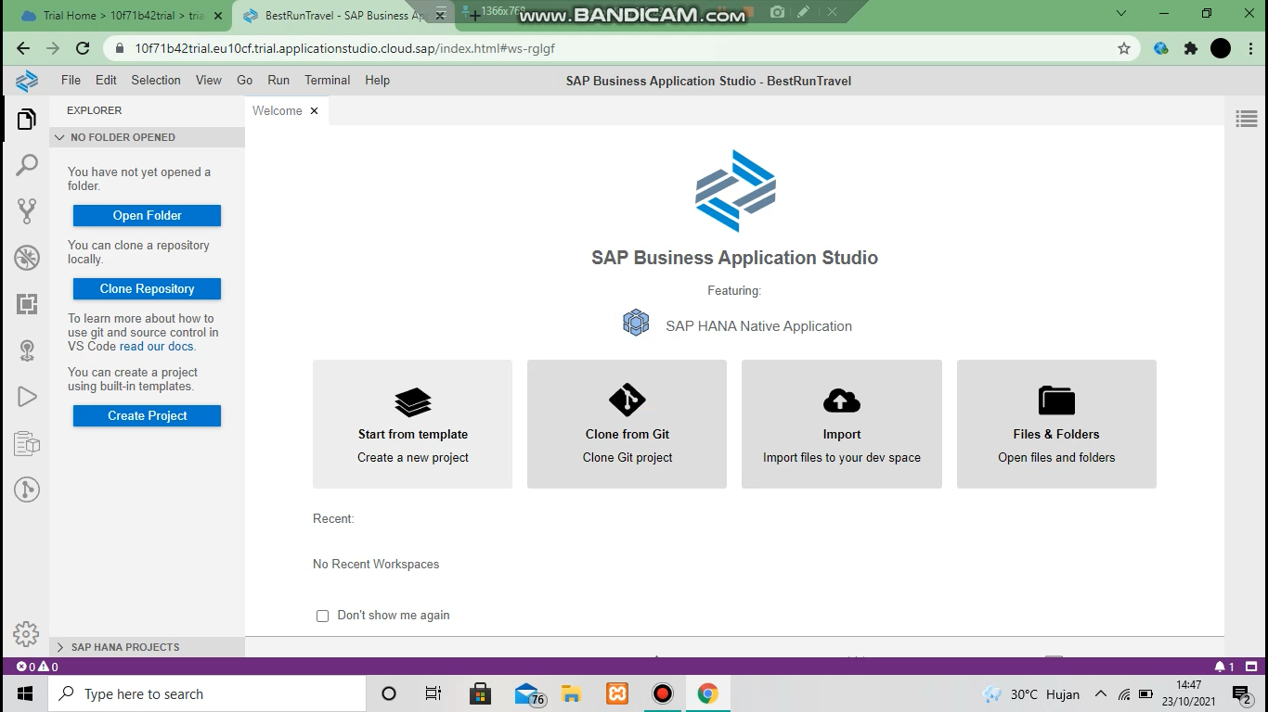

Start saphana database project

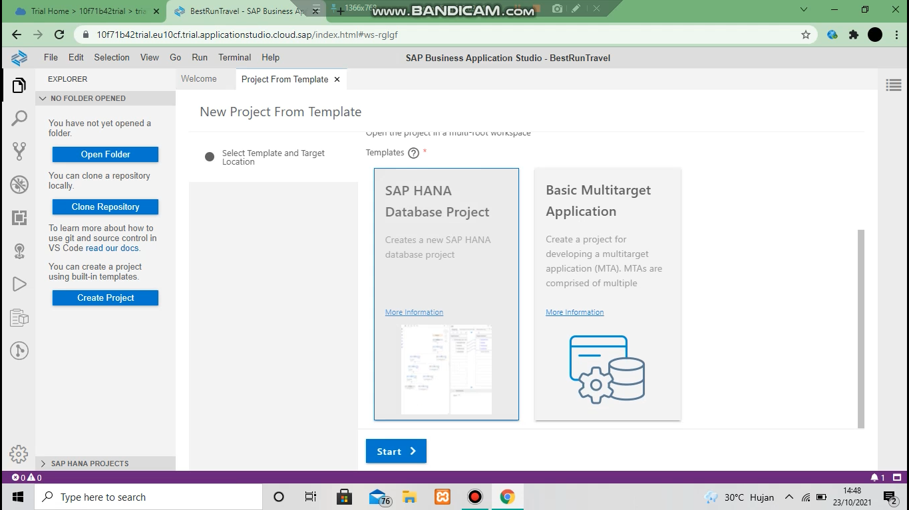

Project name : BRT_data

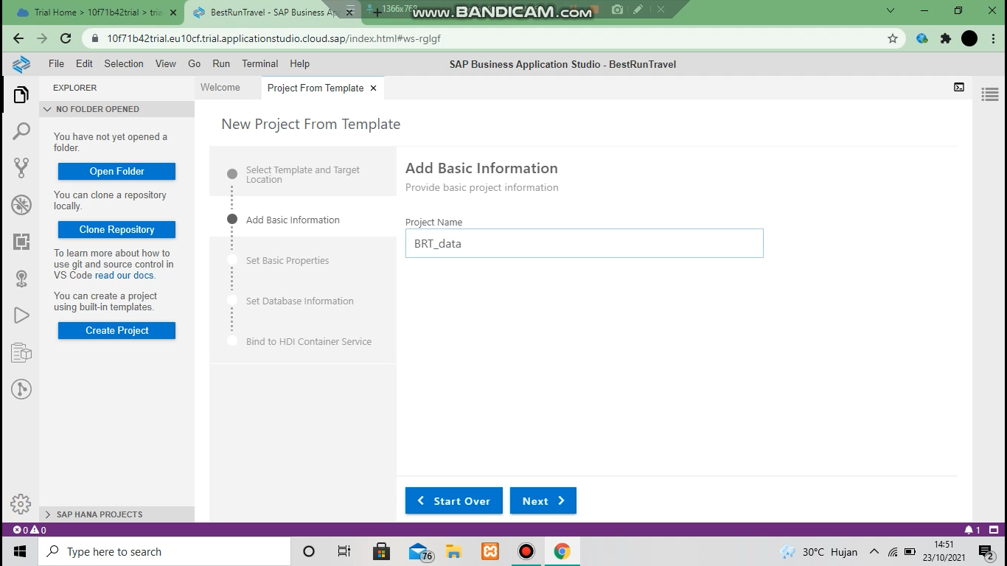

Masukkan email dan password kemudian finish

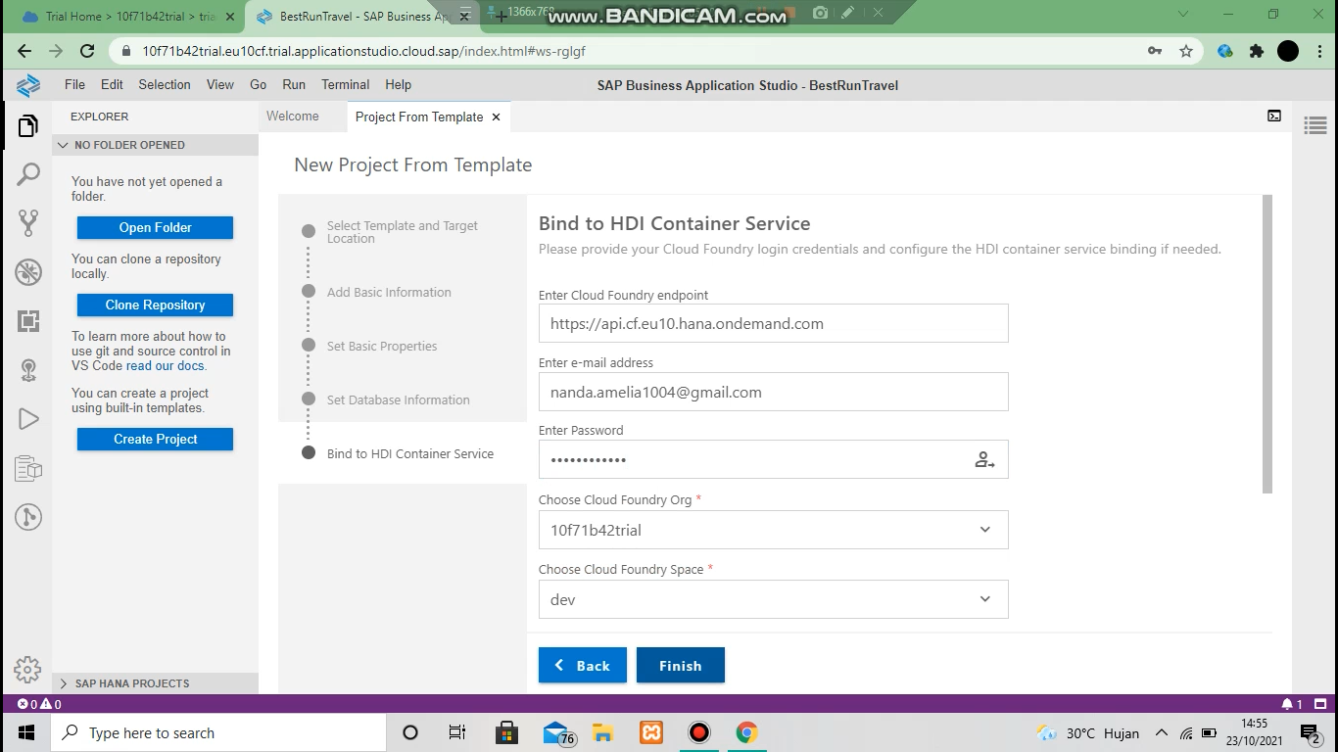

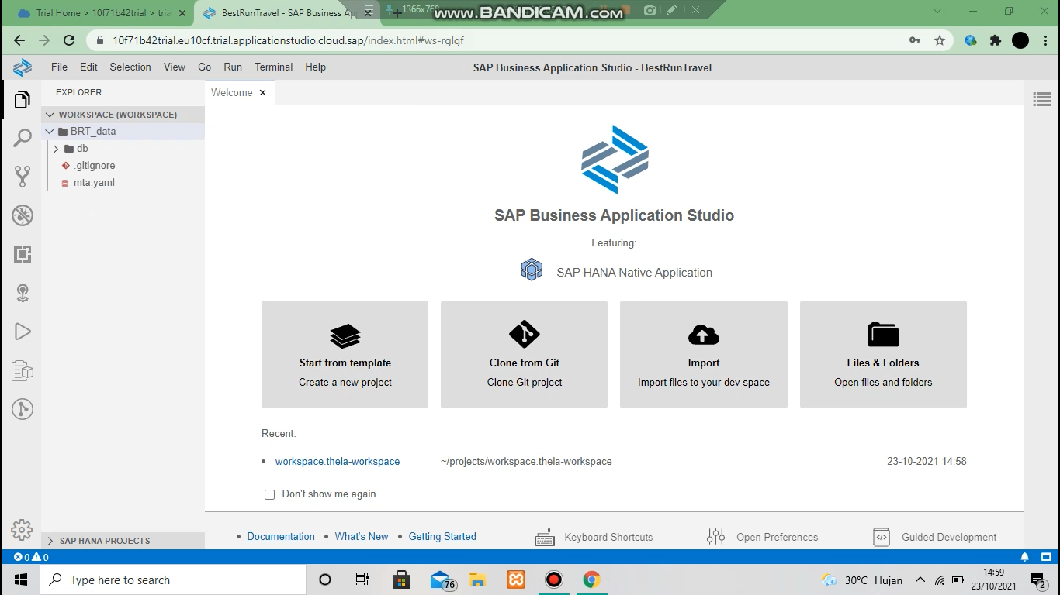

Copy sql end point

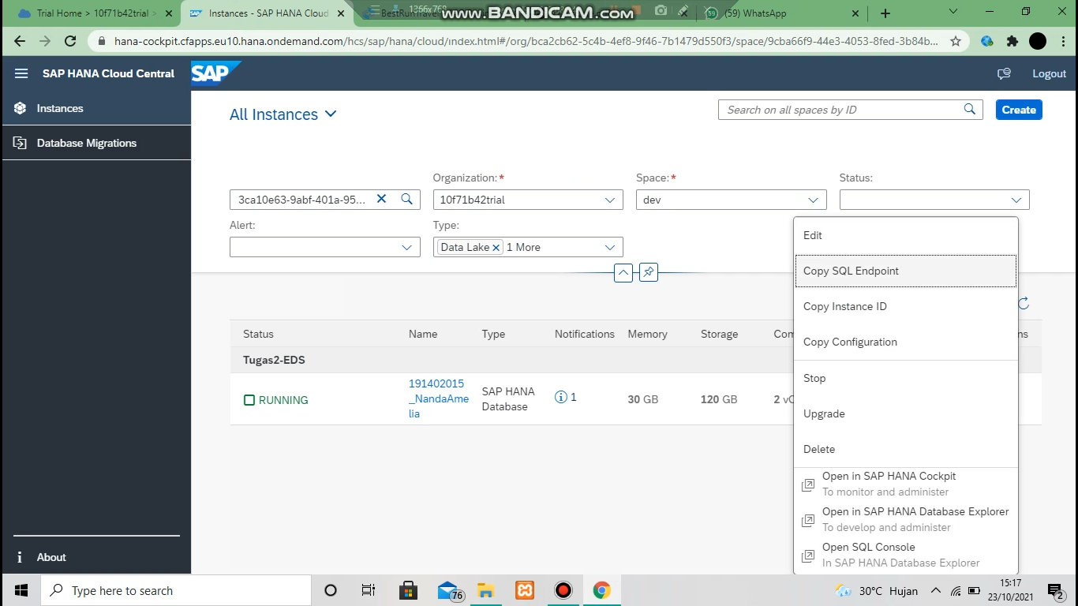

Paste kan sql ke file berikut

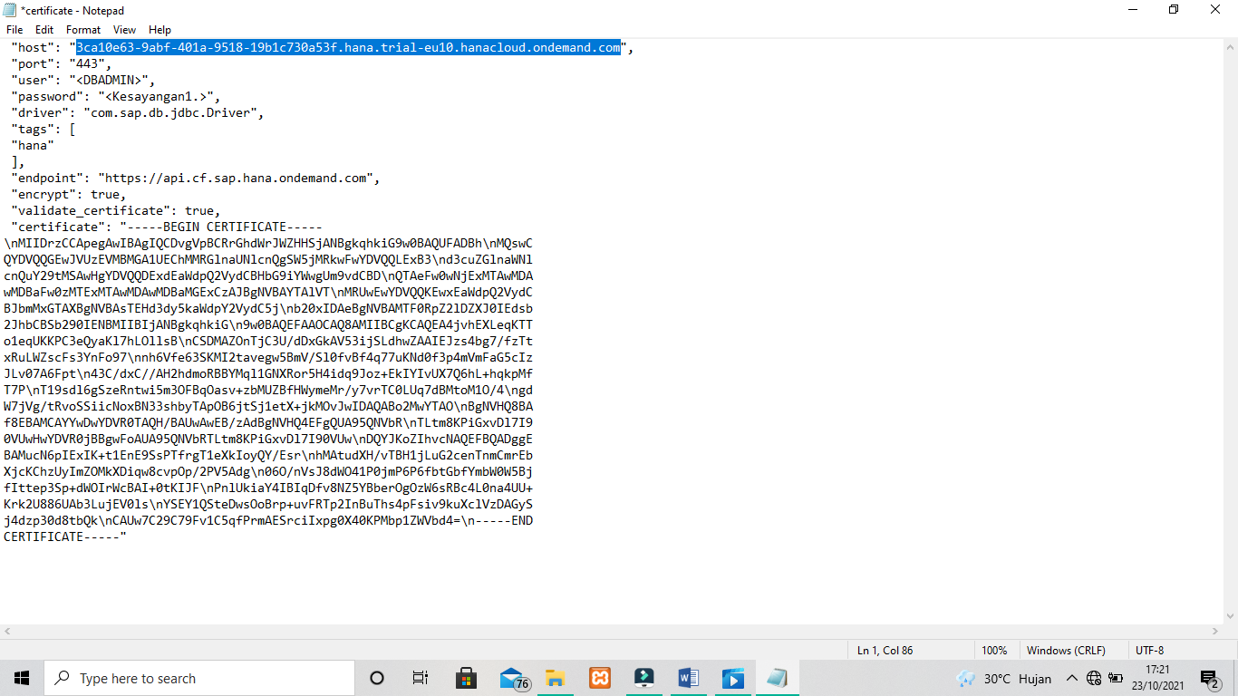

Kemudian buka view dan masukkan name MBRT, didalam {} masukkan file yang telah kita copy tadi

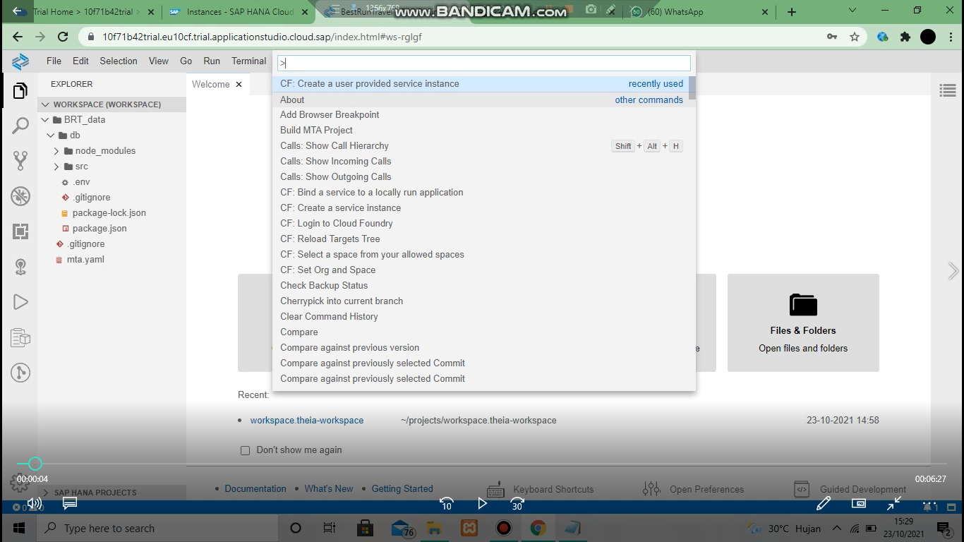

Masukkan file berikut

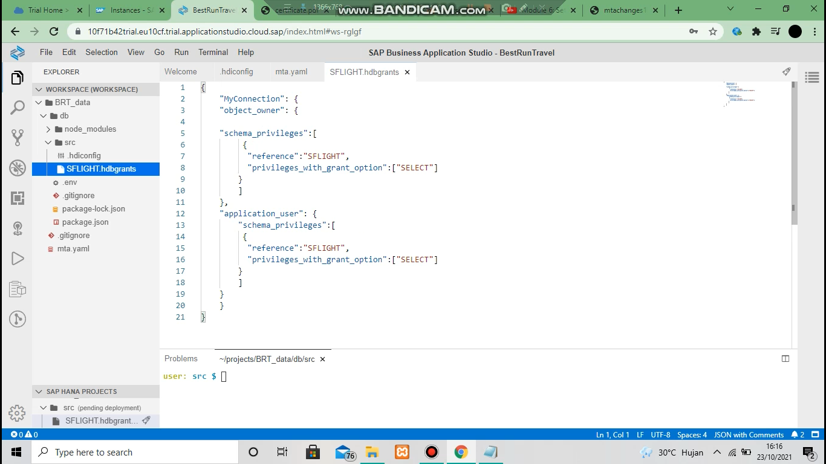

Edit file berikut menjadi seperti ini

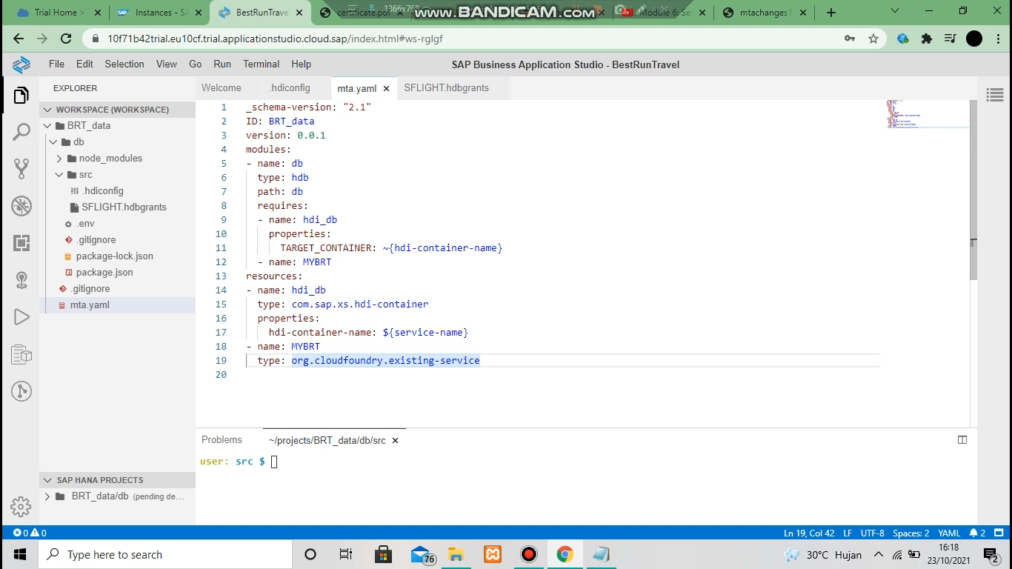

Deploy module

